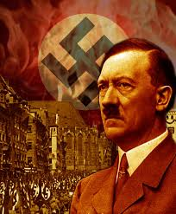
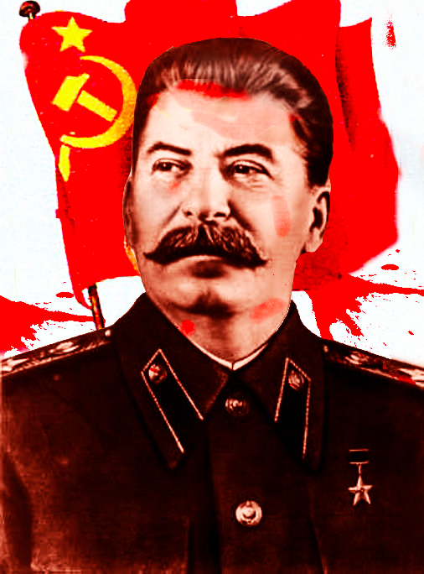
Rise of the Totalitarian Dictators
Answer the questions about the video.
https://www.youtube.com/watch?v=lPENFS7--y8

- What were the results of WWI? How did the Treaty of Versailles affect Germany?

- Describe Hitler’s childhood/background. How could someone like him come to such power in Germany at this time? How was Hitler a “good” leader? What did he do to gain power? Reference the state of Germany.

- Describe Stalin’s childhood/background. How could someone like him come to such power in Germany at this time? Reference the state of Russia.

- Compare and Contrast Hitler and Stalin.

- Put yourself in the shoes of the people. How would feel growing in this totalitarian society? How would life be different? Be as specific as possible.

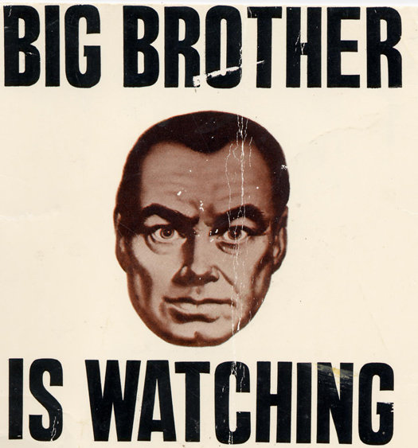
OLU Is watching you!!!

In your groups, come up with ways to make OLU a genuine totalitarian society. What would have to change (or remain the same – Haha) to make OLU a totalitarian society?

First think about the leadership.
How would the administration change? How would the teachers change? Who would be in charge?

Rules – everyone loves making up rules!
What are some laws that be enforced at OLU?

Come up with a party slogan and then explain what it means.

Explain the class system. How are women treated as opposed to men. Relationships?

Rebellion, what? How will this society deal with rebellion of any kind?

Other – anything else you would like to add that you think will help explain this new society.

